<h1>The price of this shirt is now <ins>499</ins>

        and not <del>1999</del></h1>



 <div>I m HTML and i use &lt;h1&gt;

        Header &lt; /h1&gt; tag for giving heading

    </div>

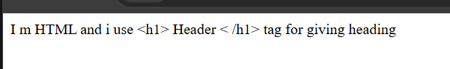

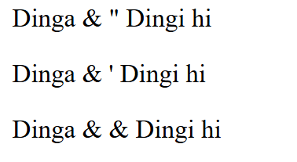 <p>Dinga & &quot; Dingi hi</p>

    <p>Dinga & &apos; Dingi hi</p>

    <p>Dinga & &amp; Dingi hi</p>

</body>

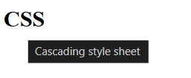

<h2 title="Cascading style sheet">CSS </h2>



<p style="color:brown;">Lorem ipsum dolor sit amet, consectetur adipisicing elit. Voluptas repellat quo eligendi

     suscipit aliquid eveniet, quaerat commodi blanditiis fugiat possimus reprehenderit deserunt quidem nam quasi,

      totam officia. Nostrum, maxime odio.</p>



 <img src="./Assets/favicn.jpg" alt="sorry" height="300px" width="300px">  
  
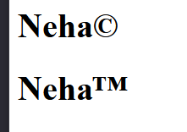

    <h1>Neha&copy;</h1>

    <h1>Neha&trade;</h1>

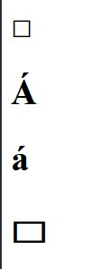  
 <h1>&square;</h1>

    <h1>&Aacute;</h1>

    <h1>&aacute;</h1>

    <h1>&rect;</h1>

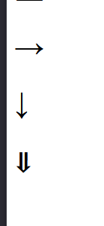

    <h1>&rarr;</h1>

   <h1>&darr;</h1>

   <h1>&dArr;</h1>

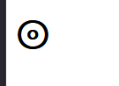  
<h1>&circledcirc;</h1>

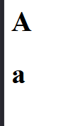  
<h1>&#x41;</h1>

<h1>&#x61;</h1>

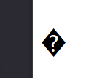  
<h1>&#x1F2600;</h1>

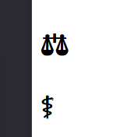  
<h1>&#x2695;</h1>



<h1>&#x2764;</h1>

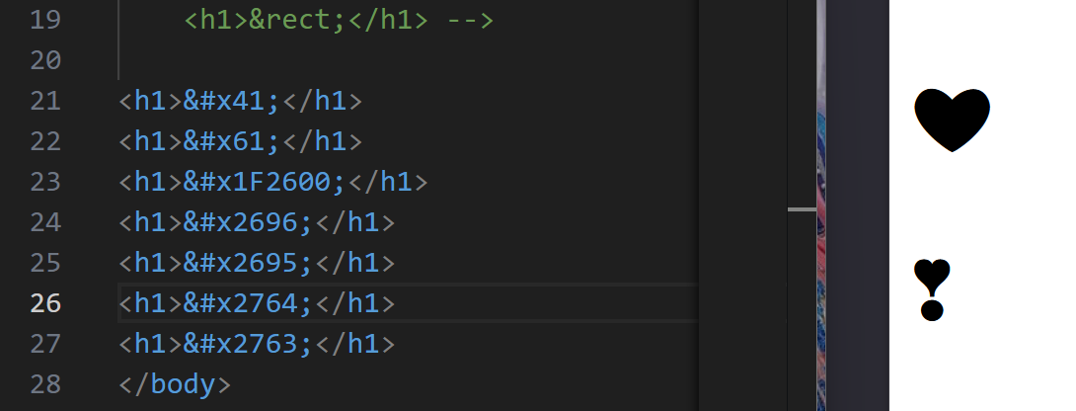  
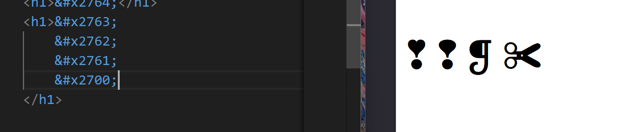  
<title>Neha</title>

    <link rel="shortcut icon" href="/Assets/favicon.jpg">

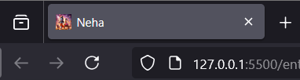  
  
 <a href="#Contact">

    <button>Contact Us</button>

</a>

    <br><br><br><br><br><br><br><br><br><br><br><br><br><br><br><br>

    <br><br><br><br><br><br><br><br><br><br><br><br><br><br><br><br>

    <br><br><br><br><br><br><br><br><br><br><br><br><br><br><br><br>

    <br><br><br><br><br><br><br><br><br><br><br><br><br><br><br><br>

    <br><br><br><br><br><br><br><br><br><br><br><br><br><br><br><br>

    <br><br><br><br><br><br><br><br><br><br><br><br><br><br><br><br>

    <section id="Contact">Contact details</section>

